**AIM:**

To implement **Depth-First Search (DFS)** traversal of a graph using an adjacency matrix.

**📘 DFS Algorithm Overview:**

1. Start from a **source vertex**.
2. Mark it as **visited** and recursively visit all its **unvisited adjacent vertices**.

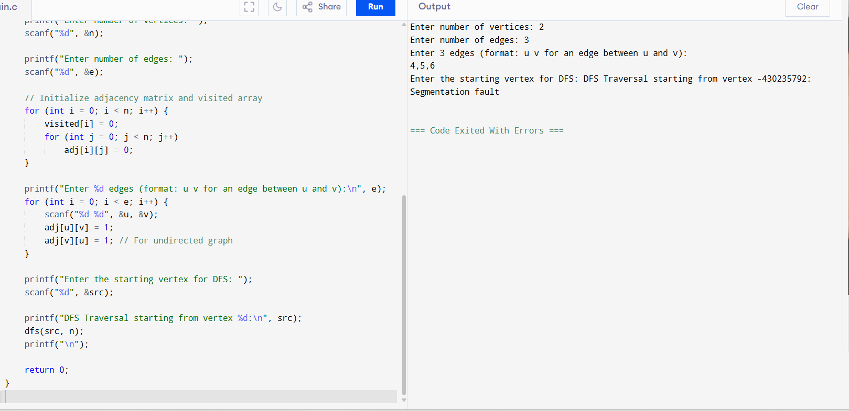

**SAMPLE OUTPUT:**

Enter number of vertices: 6

Enter number of edges: 7

Enter 7 edges (format: u v for an edge between u and v):

0 1

0 2

1 3

1 4

2 4

3 5

4 5

Enter the starting vertex for DFS: 0

DFS Traversal starting from vertex 0:

0 1 3 5 4 2